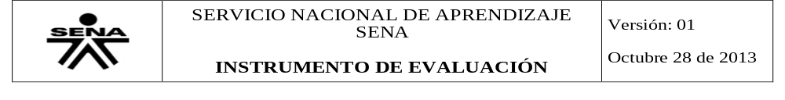
INFORMACIÓN GENERAL
CODIGO PARA IDENTIFICACIÓN DEL INSTRUMENTO: Directions-possessives-present contiuous WORKSHOP
FECHA DE APLICACIÓN: Mach 2019
PROGRAMA DE FORMACIÓN: TECNÓLOGO ADSI
ID: 1804230
CENTRO: PROCESOS INDUSTRIALES Y CONSTRUCCIÓN
CRITERIOS DE EVALUACIÓN:
*Utiliza estructuras aprendidas durante el trimestre.
*Identifica vocabulario específico y escribe textos cortos coherentes.
EVIDENCIA: Desempeño Producto Conocimiento
NOMBRE DEL APRENDIZ:
NOMBRE DEL INSTRUCTOR- TUTOR: PAOLA NATALIA OROZCO OROZCO

- Complete the conversation with Possessive Adjective
You: Hi
Tom: Hello
You: How are you?
Tom: I’m fine, thanks. How are you?
You: I’m good, thank you. What’s your name?

Tom: I’m Tom, my name is Thomas, but everyone calls me Tom.
You: Are you married?
Tom: Yes. This is my wife.
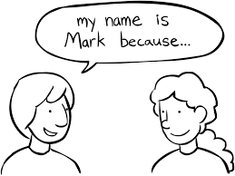
You: What is your name?
Tom: Her name is Karen.
You: Do you have kids?
Tom: Yes. This is my son.
You: What is his name?
Tom: your name is John.
You: Do you have pets?
Tom: Sure. These are its dogs.
You: What are your names?
Tom: Their names are Scooby and Smokey.
And this is it cat.
You: What’s your name?
Tom: Its name is Kitty.
You: Thank you very much.
Tom: You welcome.

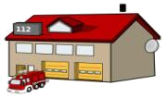
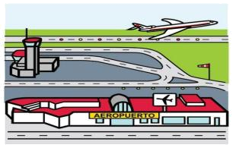
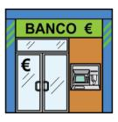
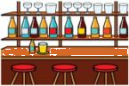
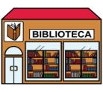
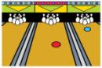

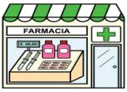
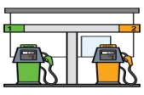
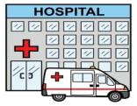
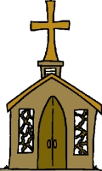
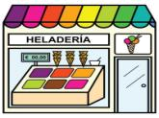
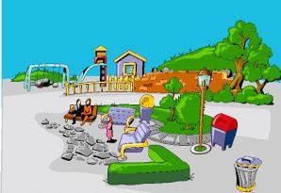
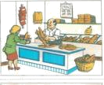
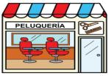
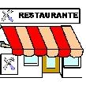
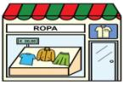
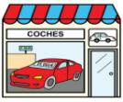
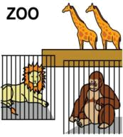
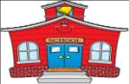
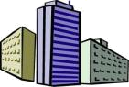

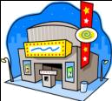
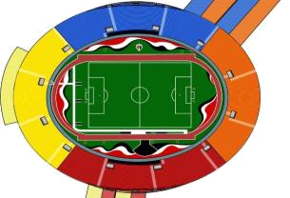
Washington Street
George Street
Stanford Avenue
Jefferson Avenue
Start
CLOTHING STORE
GARAGEE
ICE CREAM PARLOR
LIBRARY
RESTAURANT
BANK
OFFICE BUILDING
DRUGSTORE
BEAUTY PARLOR
A
B
C
D
E
F
G
H
I

DRUGSTORE

Directions:
How can I get to the library? EXAMPLE
Go straight on Stanford Avenue for 2 blocks, then turn left on Washington Street. Go down a block, the library is next to the fire station.
Where’s there a garage near here?
Go on Stanford Avenue for 1 blocks, turn right George Street 1 blocks, George Street turn Jefferson Avenue, the garage is next to Fuel station.
Where’s there a bowling place near here?
Go on Stanford Avenue for 1 blocks, turn right George Street 1 blocks, George Street turn Jefferson avenue, turn left 1 blocks Jefferson Avenue, turn Jefferson Avenue, the bowling place next to church
I need to go to a bar.
Go on to Stanford Avenue for 2 blocks, turn right Washington Street, Go 1 blocks, across turn left Jefferson Avenue, The bar next to theater.
Do you know where the zoo is?
Go on to Stanford Avenue for 2 blocks, turn right Washington Street, Across, The zoo next to theater.
How do I get to the fire station?
Go on to Stanford Avenue for 2 blocks, turn left Washington Street, Across, The fire station next to library

Answer the questions according to the picture:

Where’s the fire station?
It’s on Washington Street, next to the library.
Where’s the school?
It’s on Stanford Avenue, next to library.
Where’s the bank?
It’s on Washington Street, next to factory.
Where’s the church?
It’s on George Street, next to ice cream parlor.
Where’s the gas station?
It’s on George Street, next to garage.
Where’s the circus?
It’s on Washington Street, next to bakery.
WRITE 8 DIFFERENT PLACES IN A CITY AND SPANISH MEANING
-MALL: CENTRO COMERCIAL
- Stationery: Papeleria
-Bus station: Estacion de bus
-University: Universidad
-Pet shop: Tienda de mascotas
-Monuments: Monumentos
- Town hall: Alcaldia
-Police station: Estacion de policia
-Veterinary: Veterinaria

WHAT ARE THEY DOING? USE PRESENT CONTINOUS STRUCTURE
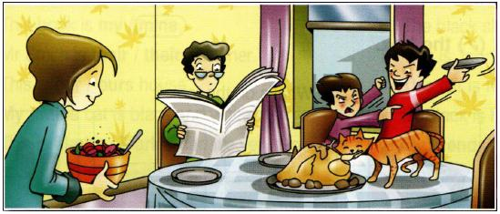

- Mom serving food.
- The father is Reading newspaper.
- The boy is holding the plate.
- The children is struggling whith the brother
- The cat eating the chiken.

Complete the sentences using presente continous structure. Use the following words in the chart
wash | cook | play | build | swim
snow | have | watching | come | do

- Top of Form
1. | I can't talk now. I Washing.the dishes.
2. | Listen to Jim. He Playing.the guitar.
3. | It snow so we can go skiing.
4. | Look at Jill. She Have in the river.
5. | They watching a new house in Fairfield.
6. | Someone Cooking I can smell the food.
7. | Hurry. The bus building
8. | They Swiming their exercises so they can lose weight.
9. | I can't answer the phone. I do a shower.
10. | Don and Jerry comming the football on TV.

